**STUDENT AND TEACHER MANAGEMENT SYSTEM**

Project Report

Subject: IT-203 Object Oriented Programming & Lab (CWS)

BACHELOR OF TECHNOLOGY IN

INFORMATION TECHNOLOGY

3rd Semester

Submitted by: VARUN KUMAR (2K19/IT/140)

YASHIT KUMAR (2K19/IT/149)

Under the Supervision of

Mrs. Geetanjali Bhola

Assistant Professor



DEPARTMENT OF INFORMATION TECHNOLOGY DELHI TECHNOLOGICAL UNIVERSITY (Formerly Delhi College of Engineering) Bawana Road, Delhi-110042

**DELHI TECHNOLOGICAL UNIVERSITY**

(Formerly Delhi College of Engineering)

Bawana Road, Delhi-110042

**CANDIDATE’S DECLARATION**

We Varun Kumar, Roll No – 2K19/IT/140 & Yashit Kumar, Roll No - 2K19/IT/149, students of B.Tech. (INFORMATION TECHNOLOGY), hereby declare that the project Dissertation titled “Student and Teacher Management System” which is submitted by us to the Department of INFORMATION TECHNOLOGY, Delhi Technological University, Delhi in partial fulfillment of the requirement for the award of the 3rd semester of the Bachelor of Technology, is made by us. This work has not previously formed the basis for the award of any Degree, Diploma Associateship, Fellowship or other similar title or recognition.

Place: Delhi

Date: 18-11-2020

Varun Kumar

Yashit Kumar

DELHI TECHNOLOGICAL UNIVERSITY

(Formerly Delhi College of Engineering)

Bawana Road, Delhi-110042

**CERTIFICATE**

I hereby certify that the Project: "**Student and Teacher Management System**" which is submitted by Varun Kumar, Roll No – 2K19/IT/140 & Yashit Kumar, Roll No – 2K19/IT/149, INFORMATION TECHNOLOGY, Delhi Technological University, Delhi in fulfillment of the requirement for the 3rd semester of Bachelor of Technology, is record of the project work carried out by the students under my supervision. To the best of my knowledge this work has not been submitted in part or full for any Degree or Diploma to this University or elsewhere.

Place: Delhi **Supervisor** : Mrs.Geetanjali Bhola

Date: 18-November-2020 (Assistant Professor)

**DEPARTMENT OF INFORMATION TECHNOLOGY**

**DELHI TECHNOLOGICAL UNIVERSITY**

(Formerly Delhi College of Engineering)

Bawana Road, Delhi-110042

**ACKNOWLEDGEMENT**

We would like to convey our heartfelt thanks to our supervisor Mrs. Geetanjali Bhola for her ingenious ideas, tremendous help and cooperation.

We are extremely grateful to our friends who gave valuable suggestions and guidance for completion of our project. The cooperation and healthy criticism came handy and useful with them.

Finally we would like to thank all the above mentioned people once again.

**TABLE OF CONTENTS**

|  |  |
| --- | --- |
| **1 . INTRODUCTION** | **6 - 8** |
| **2. FEATURES** | **9 - 12** |
| **3. OOP CONCEPT USED** | **13 – 16** |
| **4. WORKING DEMO** | **17 - 24** |
| **5. SOURCE CODE LINK** | **25** |
| **6. BIBLIOGRAPHY** | **26** |

**INTRODUCTION**

**Student and Teacher Management System** is a Project  for education establishments to manage student and teacher data

Its capabilities include the basics such as report cards, personal records of students and teacher as well as many other specialized capabilities like student grades , percentage , stream and subject toppers on console application.

This means that not only administrators but also , teachers, and students have access to real-time data.

The Student and Teacher Management System will replace the paper-based data collection and information exchange system among the various departments of a particular school.

The STMS provides an innovative solution for Today’s school record-keeping challenges.

So we decided to make C++ console based application on Student and Teacher Management System .

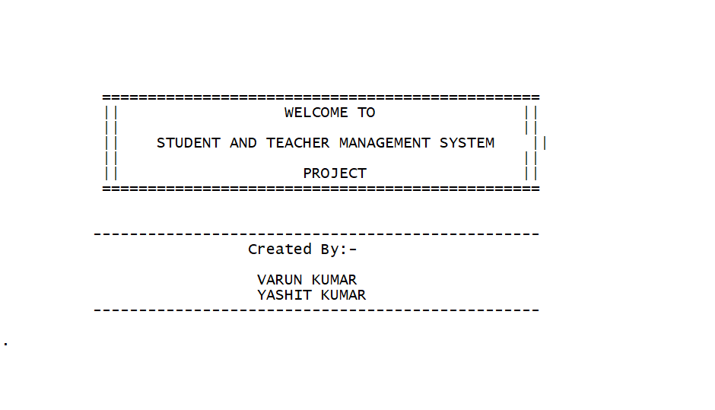

**FEATURES OF OUR PROJECT**

We have divided system into three portals : -

1. Teacher 2 . Student

3. Adminstration

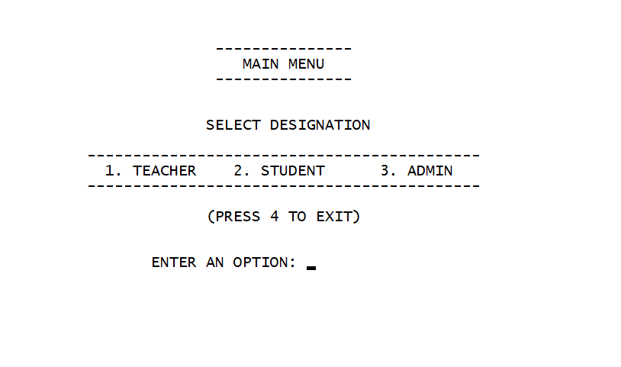

**Teacher Portal**

**1 . Enter Student Marks**

**2. Display All student Marks**

**3. Can search Student Record**

**4. Can modify Student Marks**

**5. Can delete Student Record**

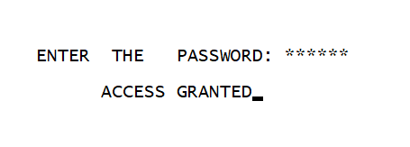

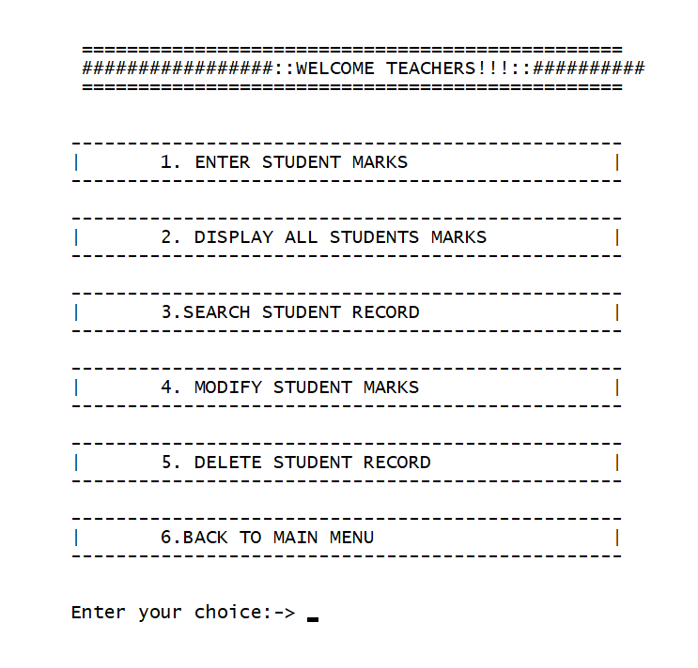

**Student Portal**

**1. Search for its record**

**2. Check Class Result Streamwise**

**3. View All Students Percentage(sorted)**

**4. View Top 5 Scorers in each subject**

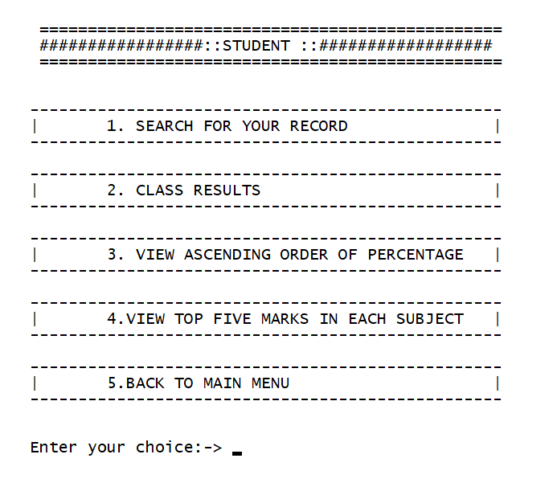

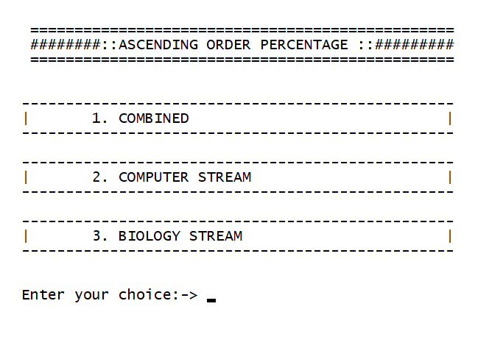

**Adminstration Portal**

**1. Class Result Streamwise**

**2. Add Teacher Record**

**3. Add Student Record**

**4. Show All Teachers Record**

**5. Show All Students Record**

**6. Delete Teacher Record**

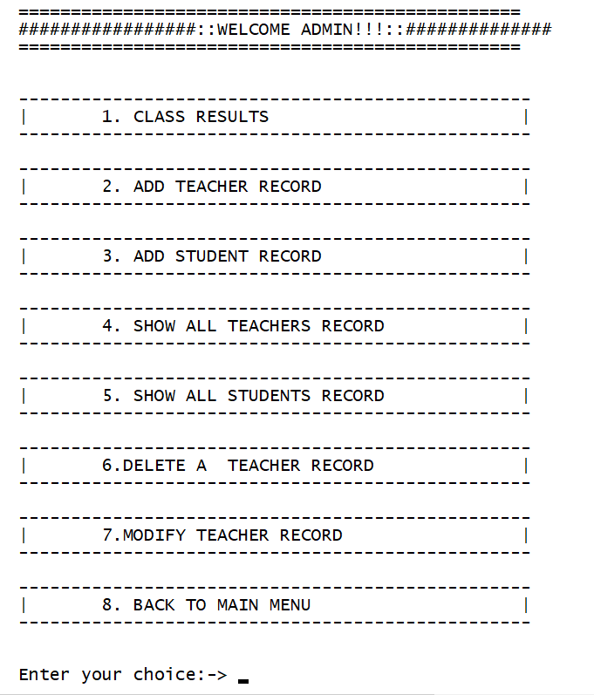**7. Modify Teacher Record**

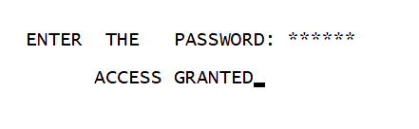

**OOP CONCEPT USED**

**Abstraction -** It is one of the most essential and important feature of object oriented programming in C++. Abstraction means displaying only essential information and hiding the details.

**Classes Created :-**

1. Person

2. Student

3. Teacher

4. Admin

**Encapuslation -** Encapsulation is defined as binding together the data and the functions that manipulates them.

All the four classes have this feature

**Friend Function / Classes Used –** A friend class can access private and protected members of other class in which it is declared as friend.

So we make class Teacher friend of class Student so that teacher can access student data

A friend function can be given special grant to access private and protected members .

Functionality Class Result and Display student marks can be used by both Student class and Teacher so we make both the functions friend .

**Inheritance -** Inheritance is one of the feature of **Object Oriented Programming** System . It allows the child class to acquire the properties (the data members) and functionality (the member functions) of parent class.

We have used **hyrid** inheritance

(D1) (Base) (D2) (D3)

**Student < ------- Person ------ > Teacher ------- > Admin**

**Exception Handling -** A C++ exception is a response to an exceptional circumstance that arises while a program is running, such as an attempt to divide by zero

It is Used when admin or teacher try to enter the information about student and enter invalid info and also it is used when the user is trying to enter wrong password at admin portal.

And also when the teacher enter marks out of range i.e above 100

When Date of Birth or phone number entered is invalid .

**File Handling -** File Handling is used to store the record of the Teacher and Student .

**WORKING DEMO**

**Adminstration Entering Student and Teacher Details**

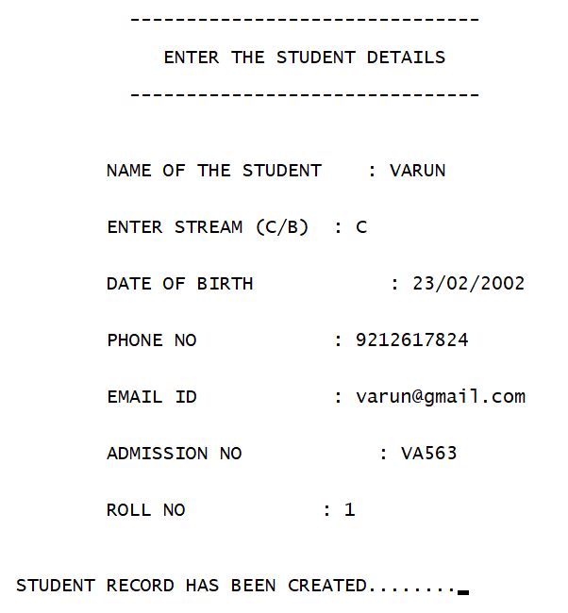

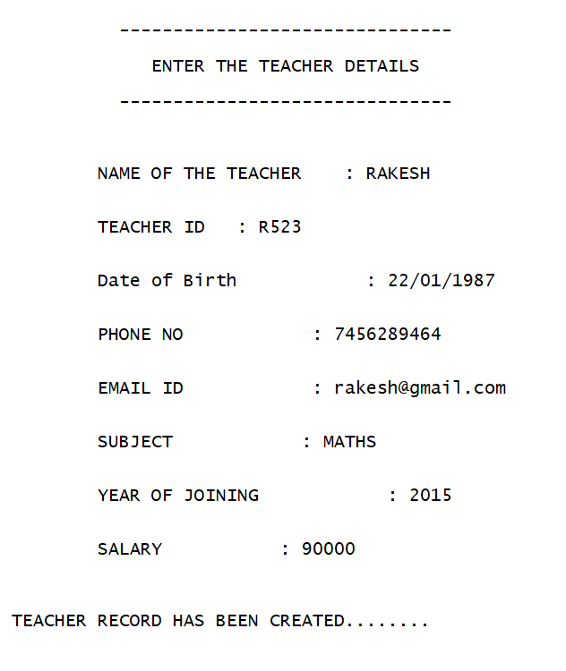

**Adminstration Modifying and Deleting Records**

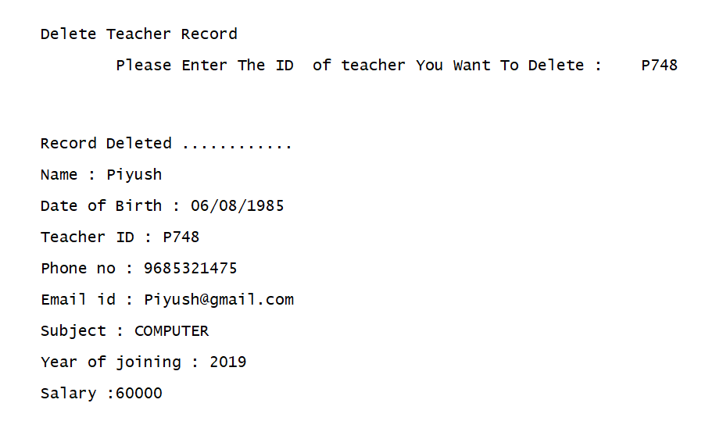

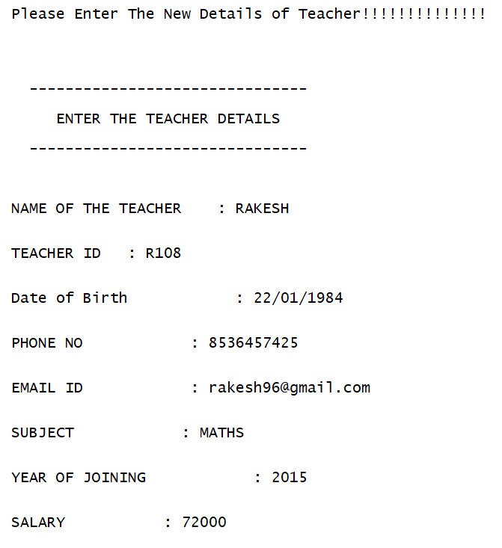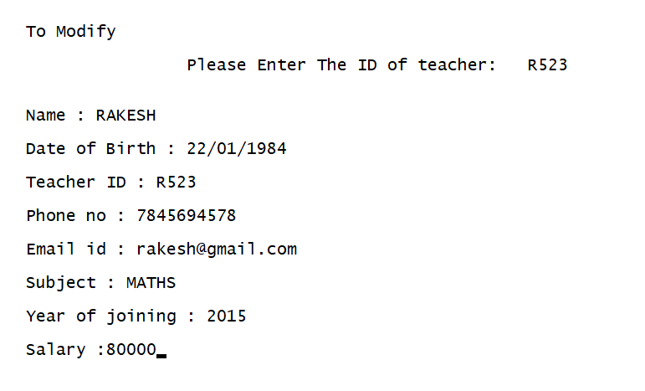

**Teacher Entering Student Marks And**

**also Modifying Marks**

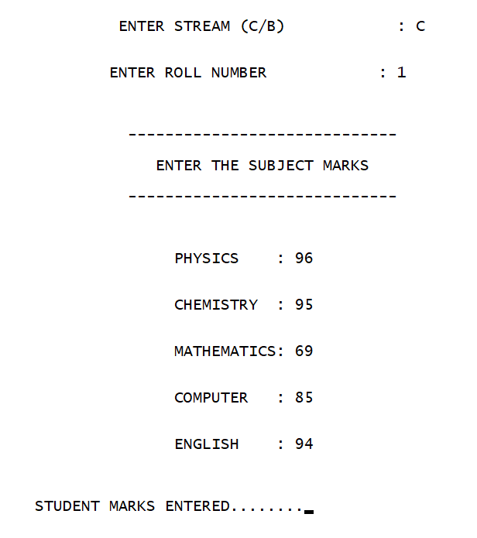

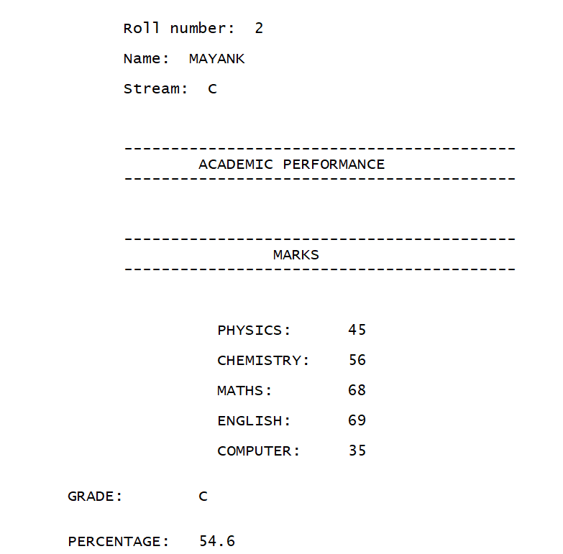

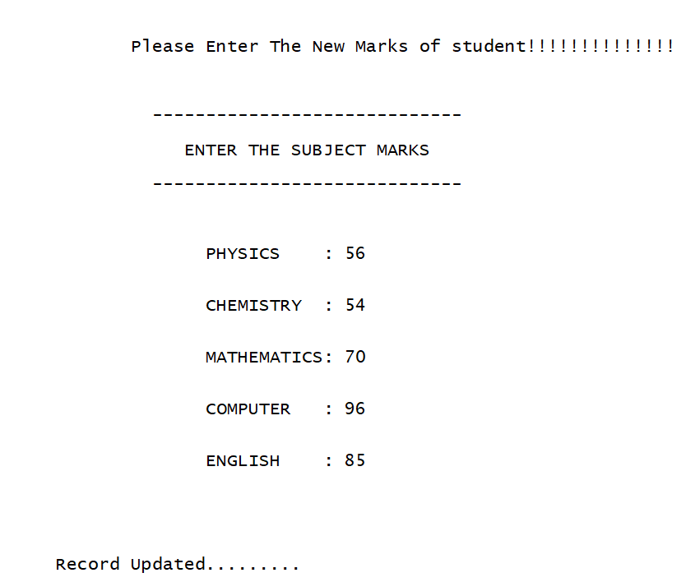

**Student or Teacher or Admin can view Streamwise Class Result**

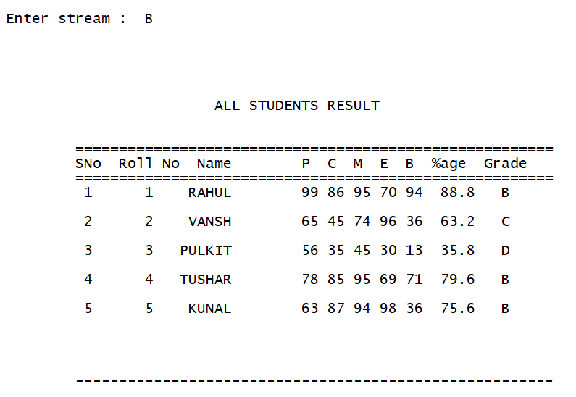

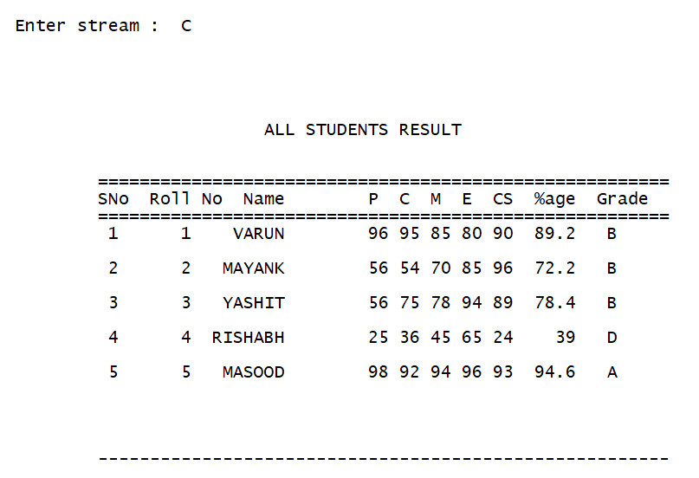

**Combined Class Result percentage Wise Sorted**

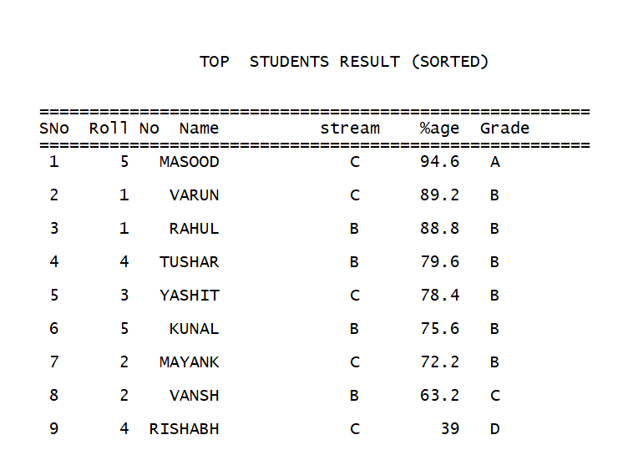

**Streamwise Result Percentage Sorted**

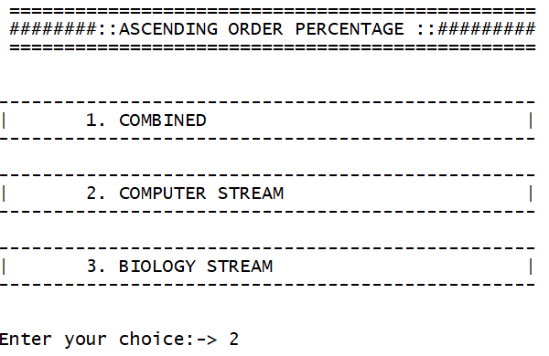

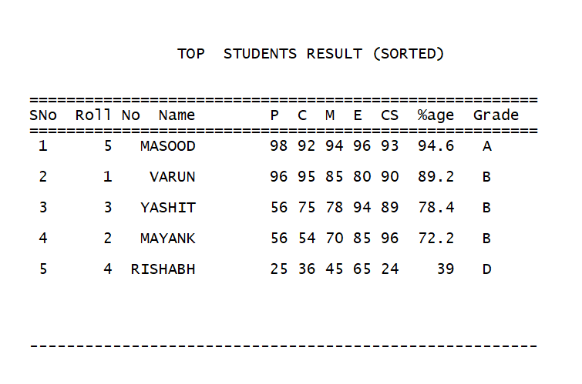

**Top 5 Scorers in each Subject**

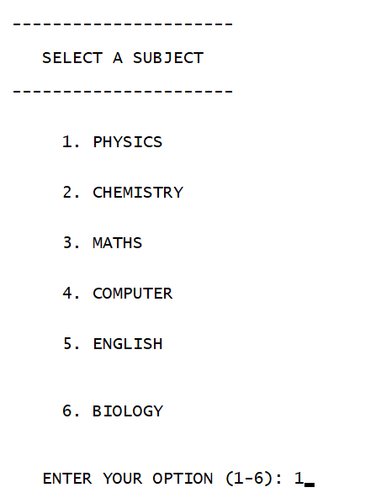

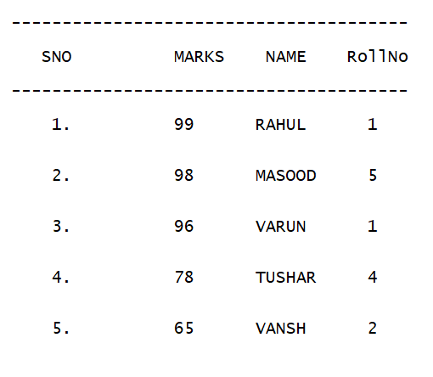

**Student can view his Record**

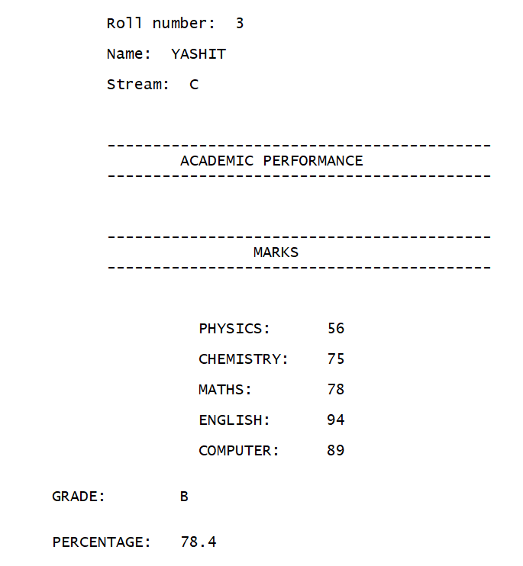

**SOURCE CODE GITHUB LINK**

**https://github.com/varunkmr038/OOP-Project/blob/main/Student%20and%20Teacher%20Management%20System.cpp**

**BIBLIOGRAPHY**

<https://www.geeksforgeeks.org/object-oriented-programming-in-cpp/>

Geetanjali Mam Notes

<https://www.geeksforgeeks.org/friend-class-function-cpp/>

[https://www.geeksforgeeks.org/file-handling-c-classes](https://www.geeksforgeeks.org/file-handling-c-classes/)